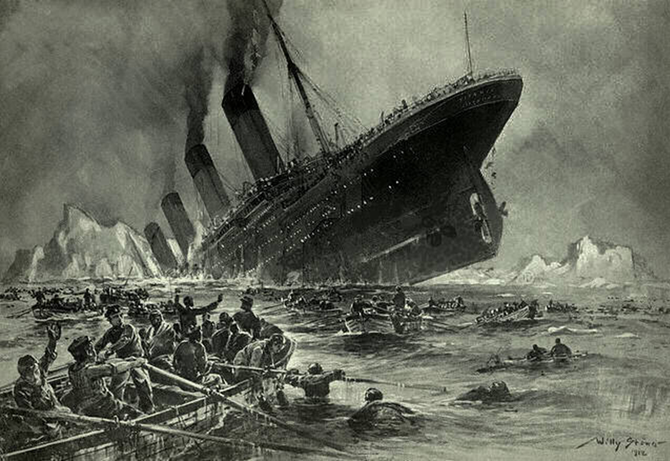

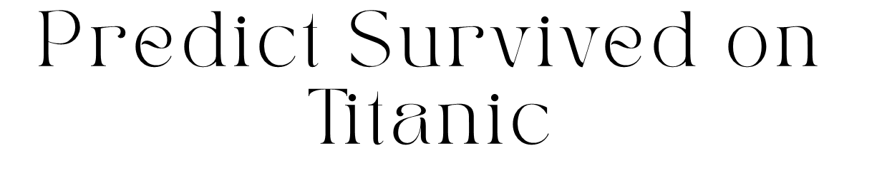

Coaching: Ho Nhut Minh

Student: Le Canh Sang - DT2210L

**Content**

1. **History of the Titanic**
2. **Why?**

* Why did I choose title?
* Why did I choose Apache Spark and Databrick

1. **About Data**

* Overview of dataset
* Data Flow

1. **EDA**

* Initialize spark on DataBricks
* EDA
* Check information before filtering data
* Drop
* Correclation

1. **Data Visualization**
2. **Machine Learning**

* Build and test Model
* Confusion Matrix Display and compare some other models
* Make prediction on Test data
* Pipeline

1. **History of the Titanic**

The history of the Titanic is one of tragedy and intrigue, spanning from its conception to its ill-fated maiden voyage.

The Titanic was a British passenger liner that was constructed by the Harland and Wolff shipyard in Belfast, Northern Ireland. It was commissioned by the White Star Line, a prominent shipping company at the time, with the intention of creating the most luxurious and technologically advanced ship of its era. Construction began on March 31, 1909, and the ship was completed two years later, on May 31, 1911.

The Titanic was touted as unsinkable, thanks to its innovative design and advanced safety features, including a series of watertight compartments. It was the largest ship afloat at the time, measuring approximately 882 feet long and 175 feet high, and it boasted amenities such as luxurious cabins, opulent dining rooms, and even a swimming pool and gymnasium.

On April 10, 1912, the Titanic set sail on its maiden voyage from Southampton, England, bound for New York City. Among its passengers were some of the wealthiest and most prominent figures of the time, along with hundreds of immigrants seeking a new life in America.

Disaster struck on the night of April 14, 1912, when the Titanic collided with an iceberg in the North Atlantic Ocean. Despite efforts to avoid the iceberg and mitigate the damage, the ship began to take on water rapidly. In the early hours of April 15, 1912, the Titanic sank beneath the icy waters, taking more than 1,500 souls with it.

The sinking of the Titanic remains one of the deadliest maritime disasters in history and has captured the public imagination for over a century. Investigations into the causes of the tragedy revealed a combination of factors, including inadequate safety procedures, overconfidence in the ship's design, and a lack of sufficient lifeboats.

The sinking of the Titanic sparked widespread reforms in maritime safety regulations, leading to the establishment of stricter guidelines for ship construction, emergency procedures, and the provision of life-saving equipment. Despite its tragic end, the Titanic continues to captivate the imagination of people around the world, serving as a poignant reminder of the perils of hubris and the fragility of human life.

1. **Why?**

**Why did I choose this title?**

Choosing the Titanic dataset for data analysis is a common decision in the machine learning and data science community for several reasons:

**Popularity**: The Titanic dataset is one of the most popular datasets in the field of machine learning. Due to the fame of the Titanic event, many people are interested in and seek information about it.

**Accessibility**: This dataset is publicly available and easily accessible through various sources on the Internet, including the official websites of Kaggle and GitHub. This makes it a valuable resource for learning and research purposes.

**Suitability for Learning and Experimentation:** The Titanic dataset provides information on variables such as age, gender, ticket class, and embarkation point, making it an ideal choice for experimenting with basic machine learning algorithms and developing data analysis skills.

**Large and Diverse:** This dataset is large and diverse enough to reflect various aspects of the Titanic event, from general patterns and trends to specific details and variations. This creates opportunities for various approaches to data analysis.

In summary, choosing the Titanic dataset for data analysis not only brings benefits for learning and research but also helps provide insights into applying machine learning and data science in practice.

**Why did I choose Apache Spark?**

Choosing Apache Spark for data analysis can be advantageous for several reasons:

**Speed**: Apache Spark is known for its high-speed processing capabilities, making it suitable for handling large-scale datasets efficiently. It can perform in-memory computing, which significantly speeds up data processing compared to traditional disk-based processing systems.

**Scalability**: Apache Spark is designed to scale horizontally, meaning it can easily handle increasing amounts of data by adding more computational resources. This scalability makes it ideal for big data processing tasks where the volume of data is constantly growing.

**Versatility**: Apache Spark supports multiple programming languages, including Scala, Java, Python, and R, providing flexibility for developers and data scientists to work with their preferred language. Additionally, it offers a wide range of libraries for various data processing tasks, such as Spark SQL for structured data processing, MLlib for machine learning, and GraphX for graph processing.

**Fault Tolerance**: Apache Spark provides built-in fault tolerance mechanisms, ensuring that data processing tasks are resilient to failures. It automatically recovers from failures by re-computing lost data partitions, thereby minimizing the risk of data loss and ensuring the reliability of data analysis workflows.

**Integration**: Apache Spark integrates seamlessly with other big data technologies and frameworks, such as Hadoop, HDFS, and Apache Kafka. This interoperability allows organizations to leverage their existing infrastructure investments and integrate Spark into their data pipelines easily.

Overall, the speed, scalability, versatility, fault tolerance, and integration capabilities of Apache Spark make it a compelling choice for data analysis tasks, especially in environments dealing with large and complex datasets.

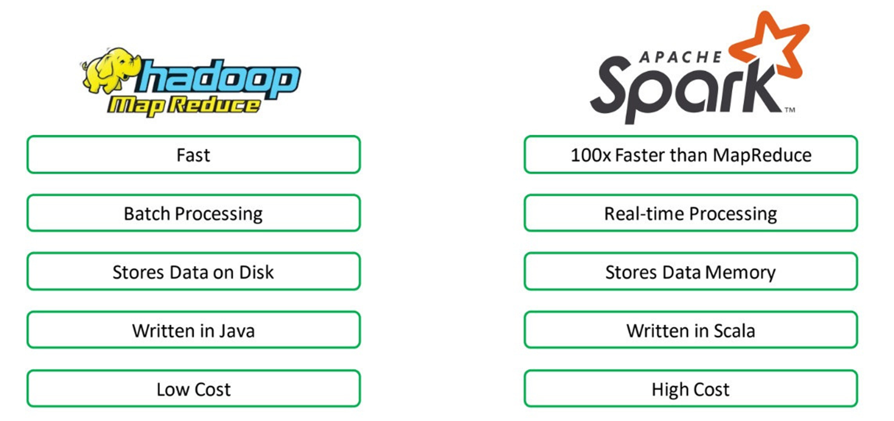

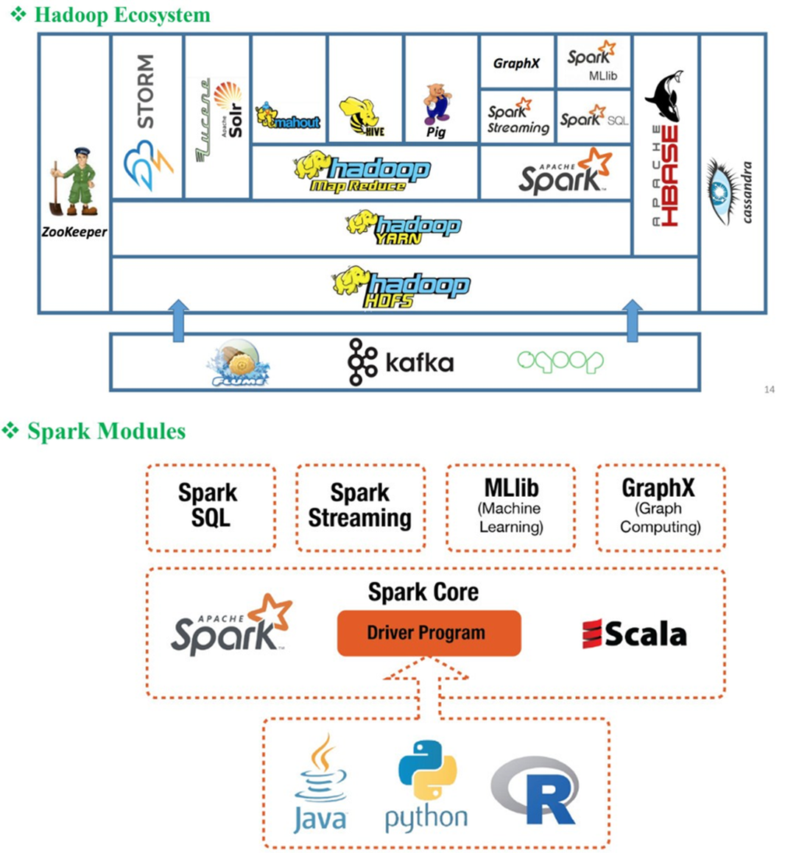



Databricks is a cloud-based data analysis platform built on Apache Spark, focusing on providing a unified and integrated workspace for data analysts. With features like integration with Apache Spark, collaborative working environment, and automatic scalability, Databricks helps optimize performance and reduce deployment time for data analysis projects.

1. **Overview of dataset and Dataflow**

**Overview of dataset**

Data Soucre from Kaggle: <https://www.kaggle.com/competitions/titanic>

This Project has 2 files csv: **train.csv, test.csv**

**file** : **train**.**csv** (891 elements), **test**.**csv**(413 elements)

**PassengerId**: Passenger ID.

**Survived**: Target variable, representing whether the passenger survived (1) or not (0).

**Pclass**: Passenger class.

**Name**: Passenger's name.

**Sex**: Passenger's gender.

**Age**: Passenger's age.

**SibSp**: Number of siblings or spouses accompanying.

**Parch**: Number of parents or children accompanying.

**Ticket**: Ticket number.

**Fare**: Ticket price.

**Cabin**: Passenger cabin.

**Embarked**: Port of embarkation.

But file **test**.**csv** not has Survived column. So I must make prediction model for predict who survived

**Train.csv**

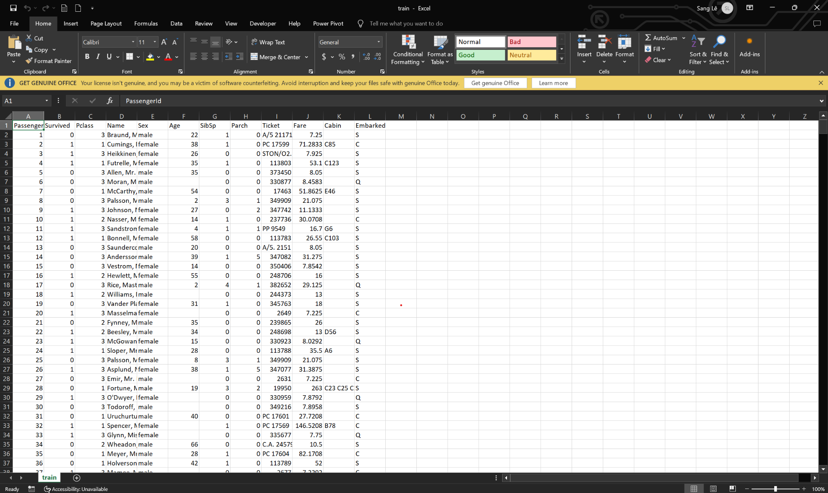

**Test.csv**



**Dataflow**

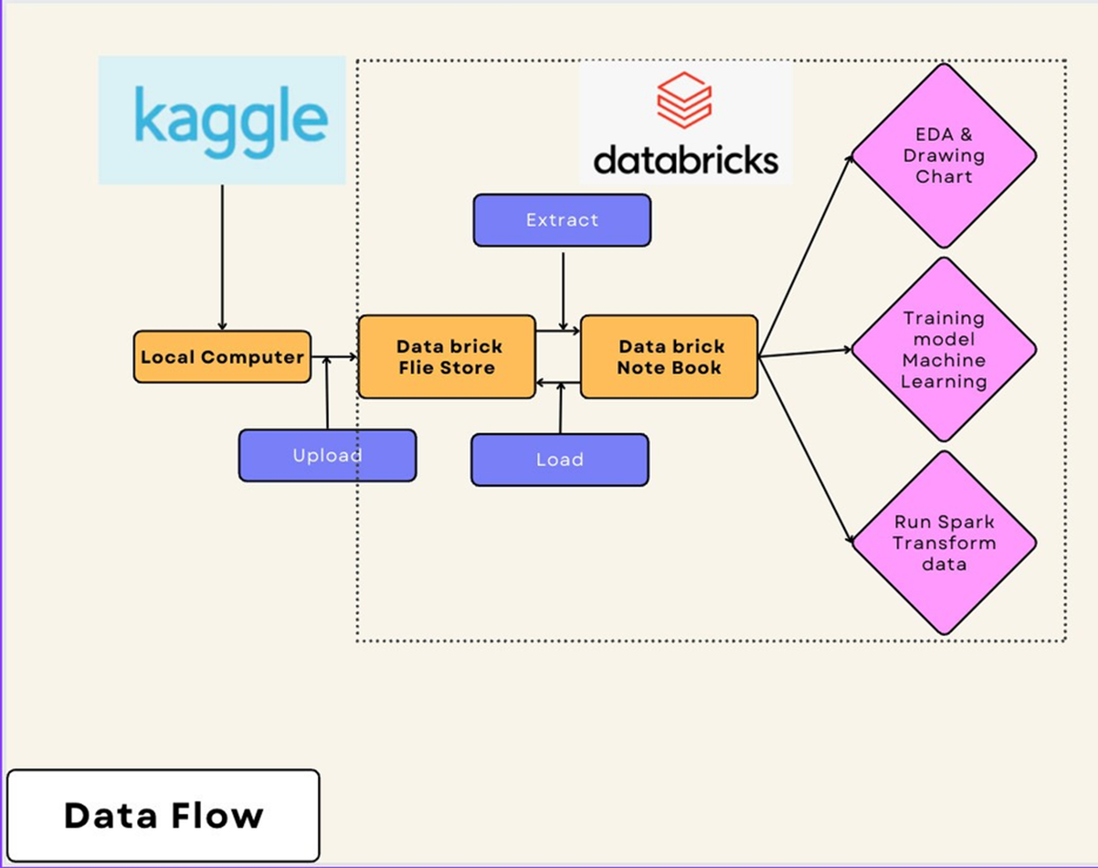

1. **EDA**

**Initialize spark on DataBrick**

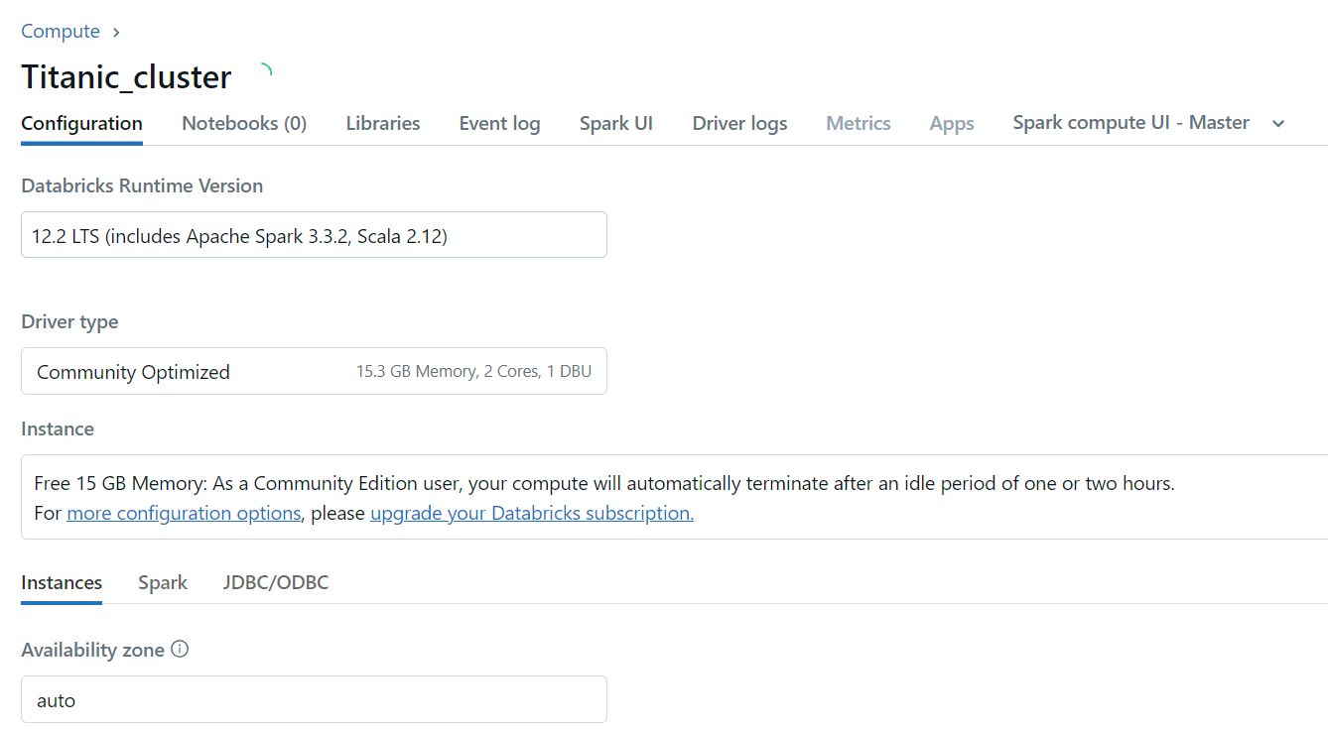

First step, I create Cluster on Databrick

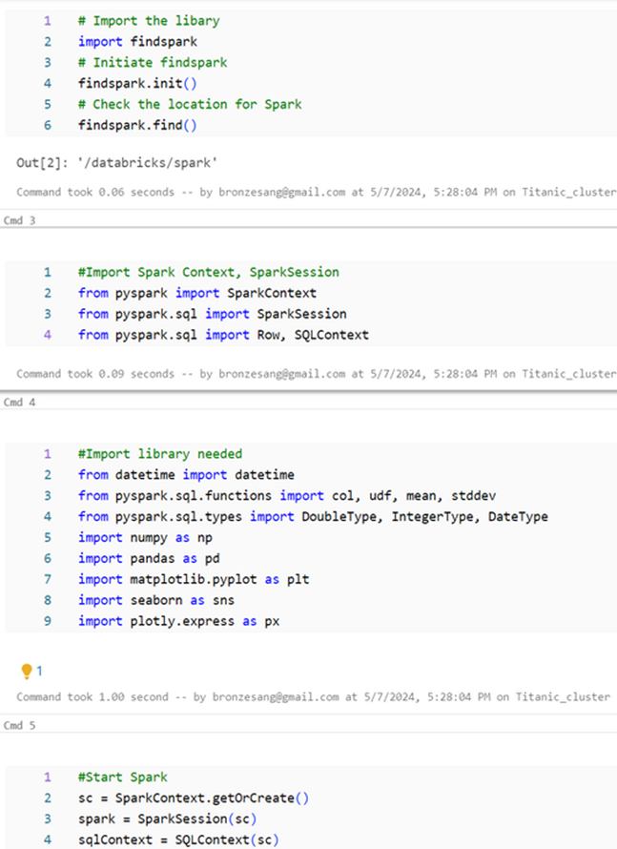

Second I import pyspark and library needed and start **SPARK** in Databrick

**EDA**

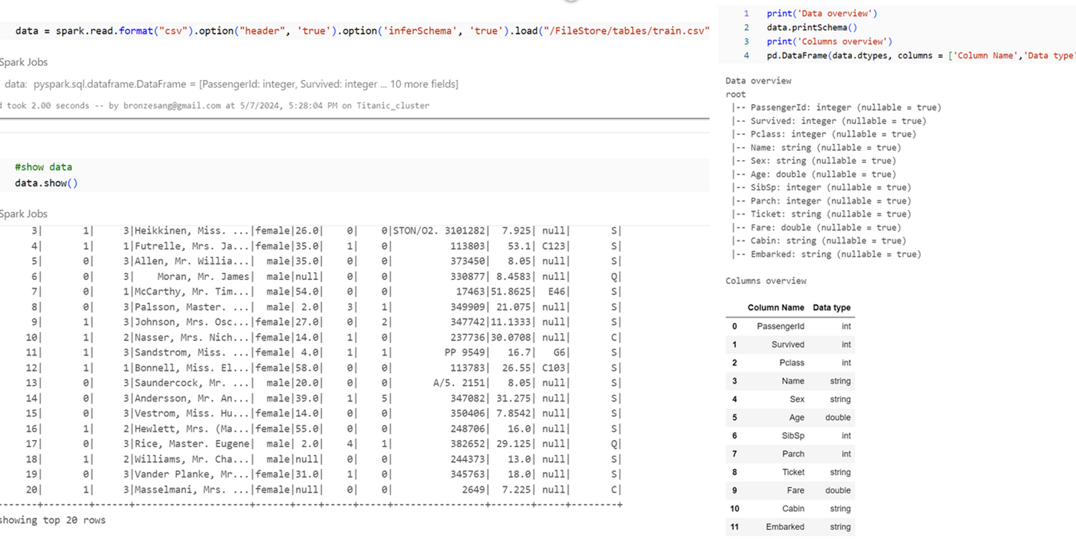

Load file train.csv, and show **Dataframe** and **printSchema()**

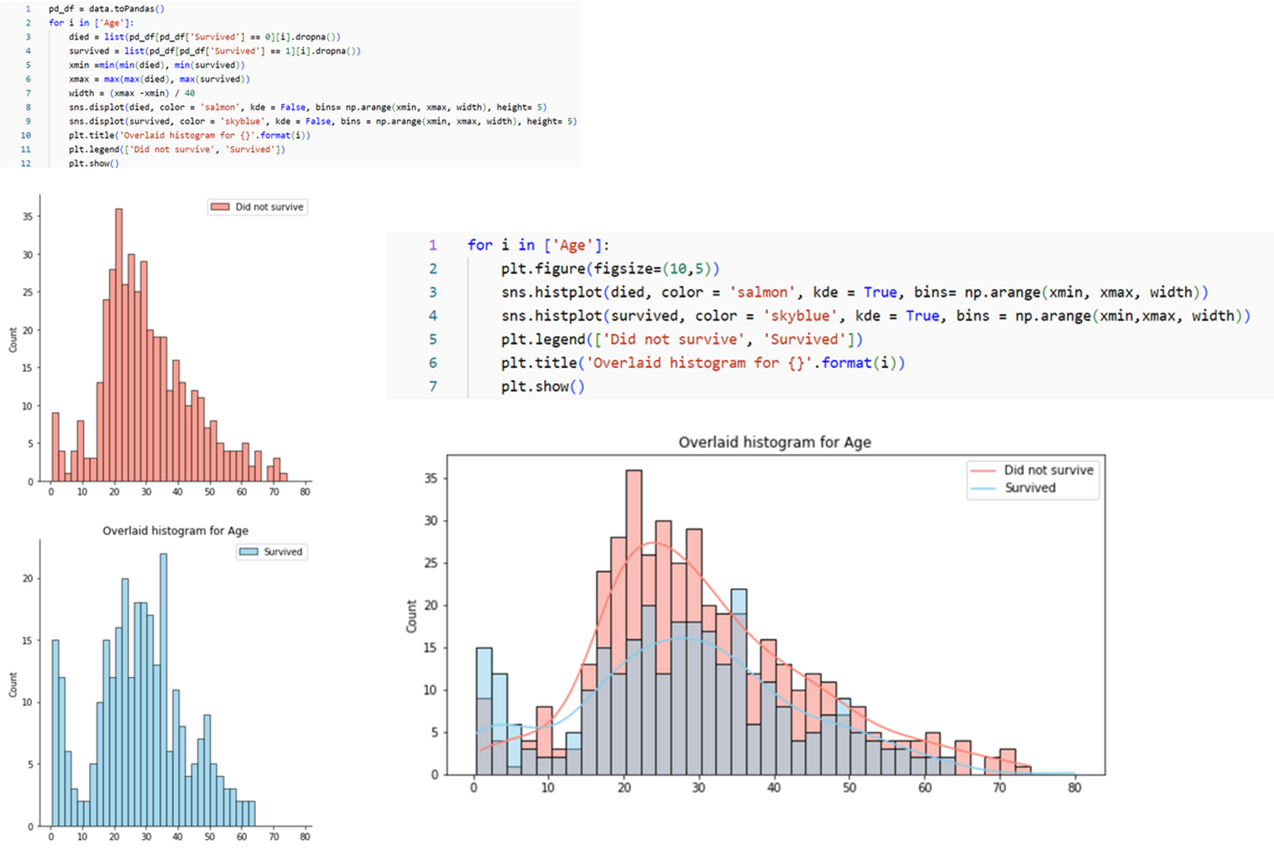

Compare survivors age before EDA

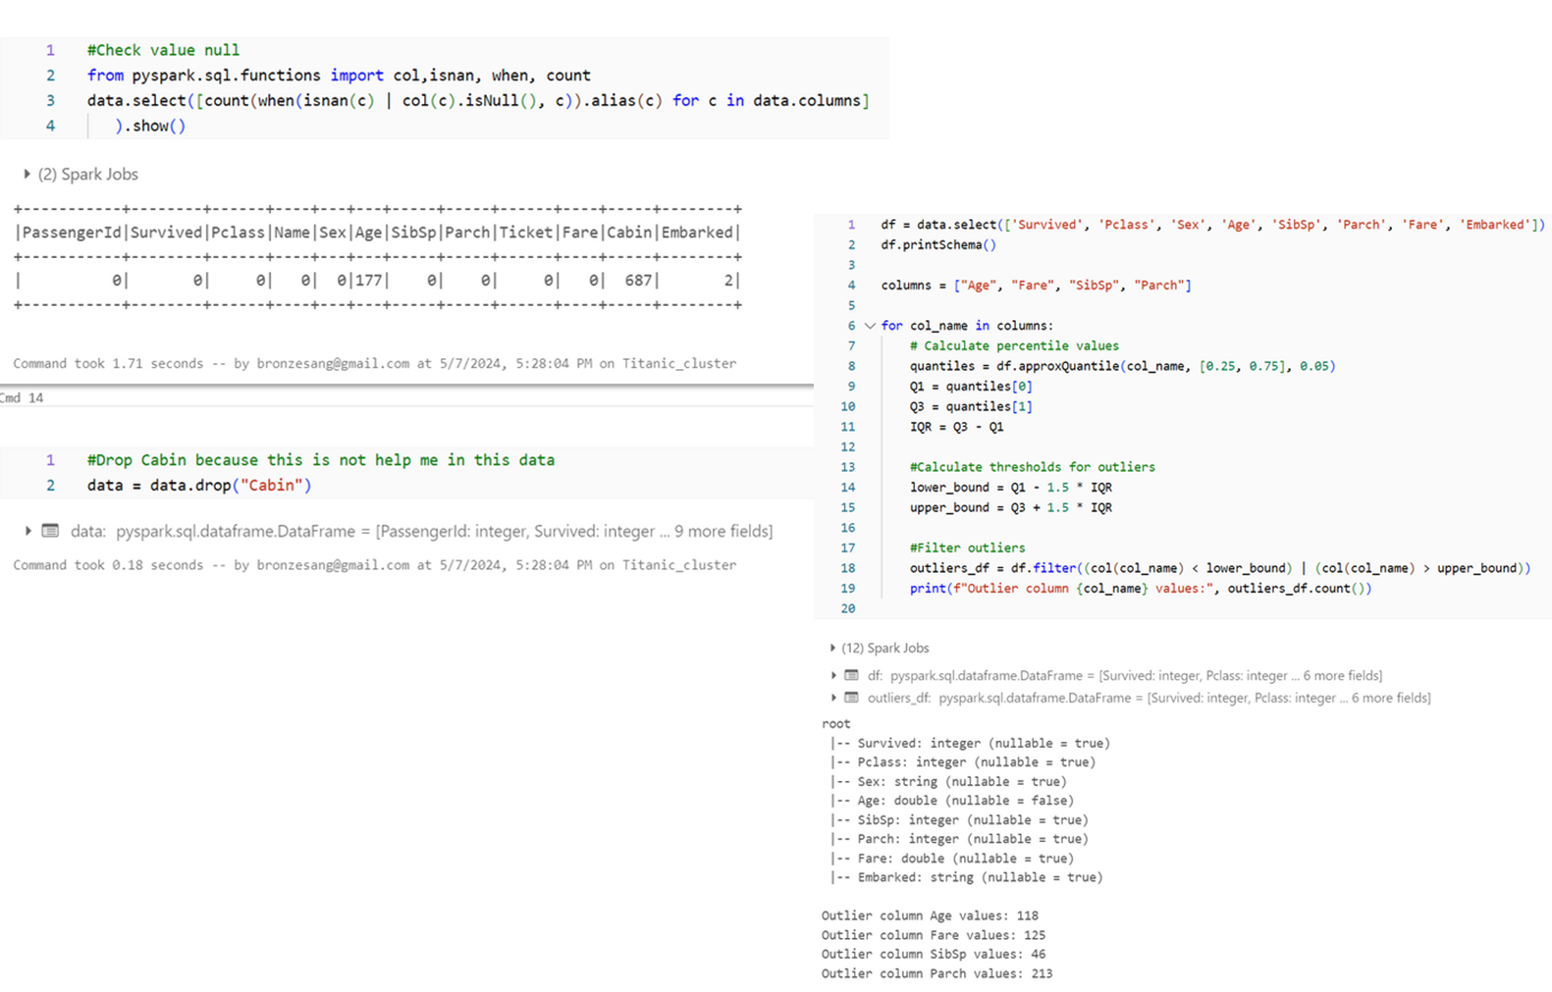

Check null values of data

The columns have null values: Age(177), Cabin(687), Embarked(2)

Check outlier values of columns I will using for features

The columns have outlier values: Age(118), Fare(125), Sipsp(46), Parch(213)

**Check information before filtering data**

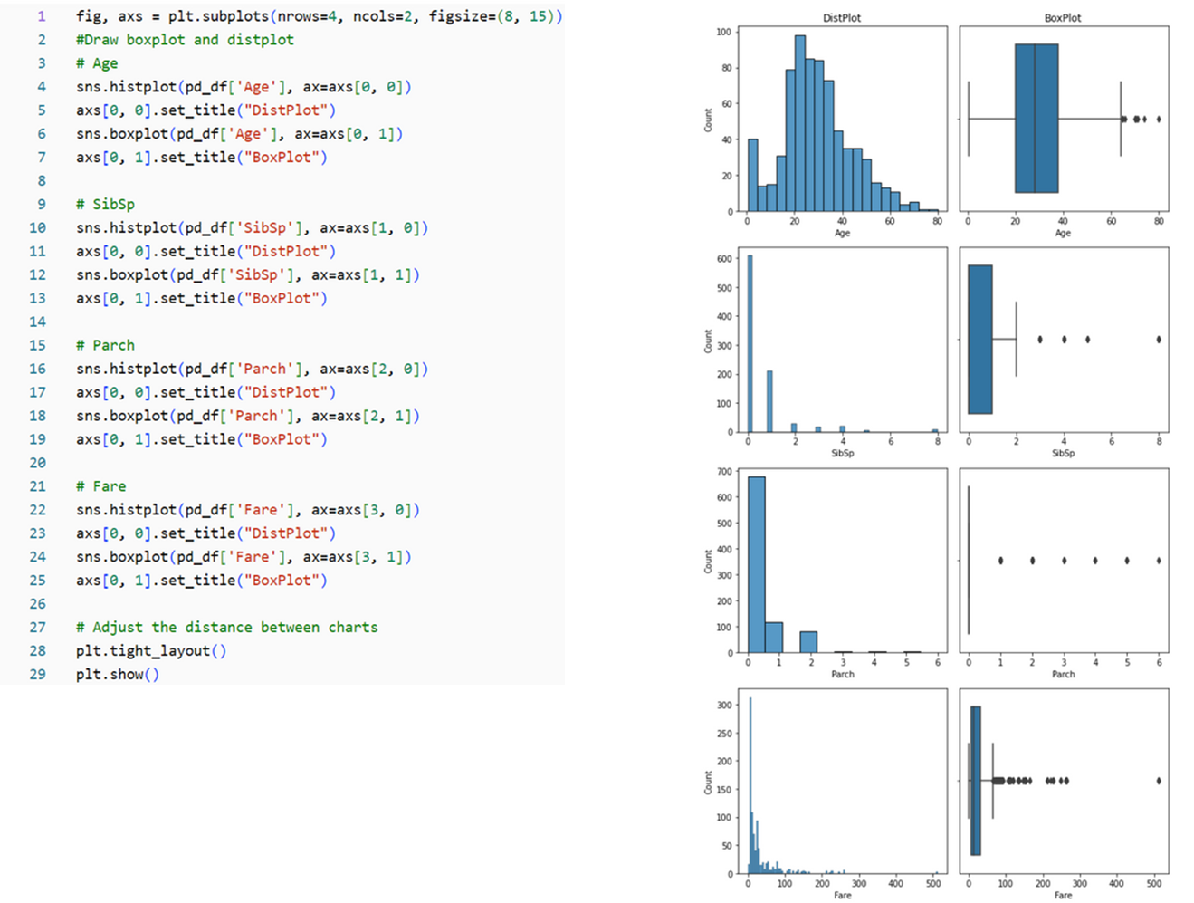

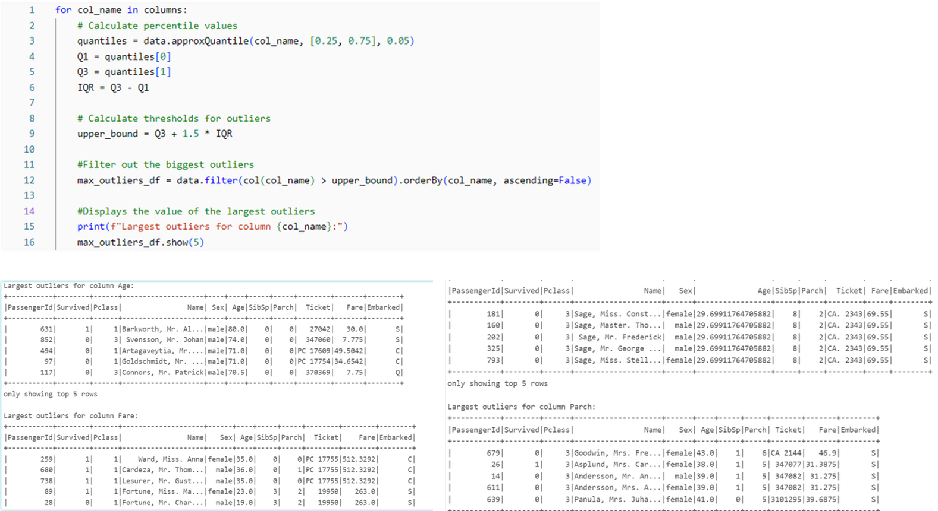

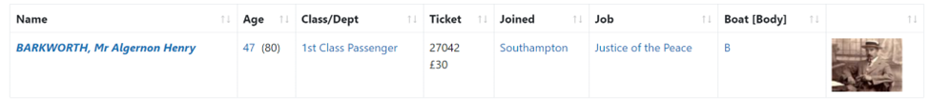

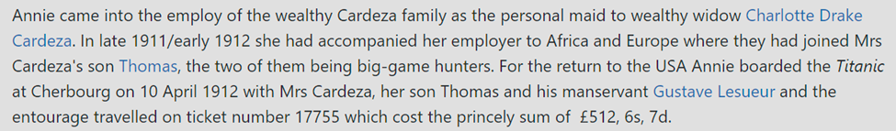

Because outlier values are **real**, so we still use and don’t drop it

**Drop**

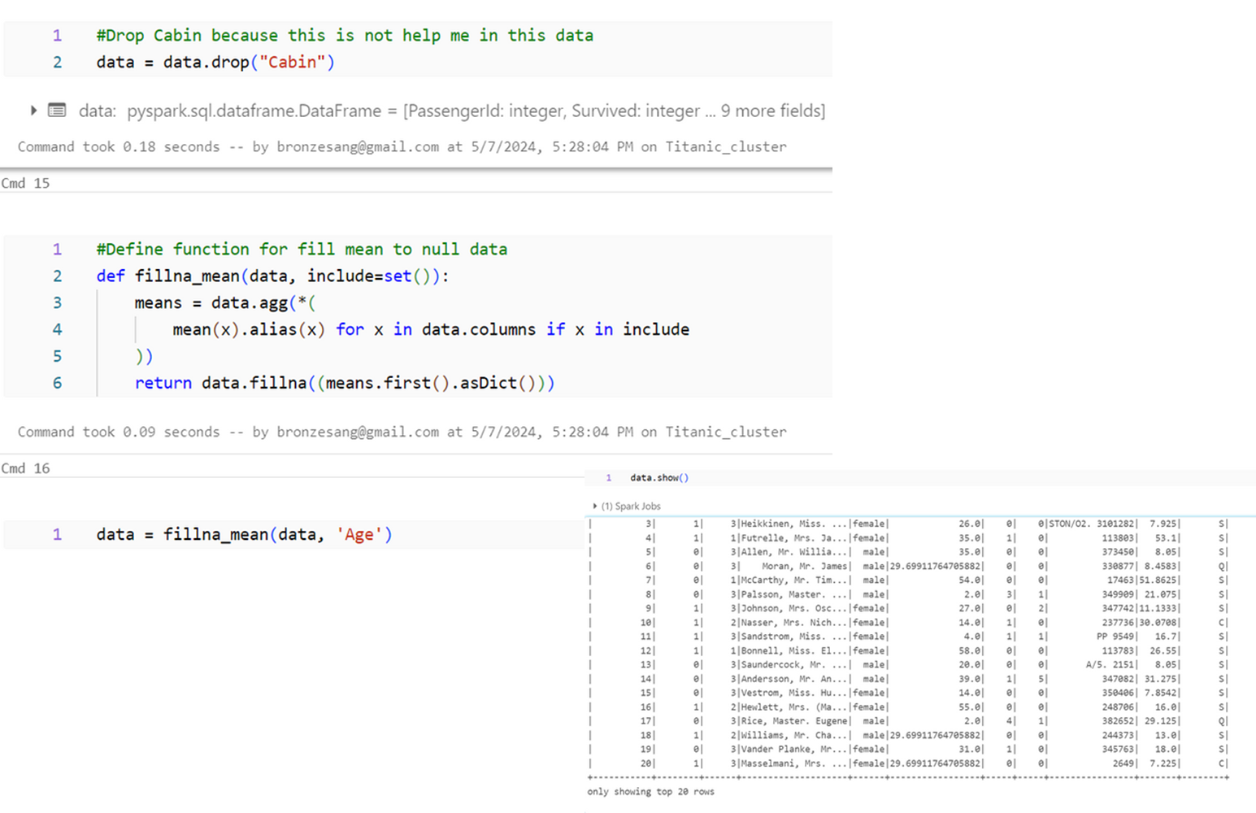

I will drop column “**Cabin**”, because I don’t need it, and fill null values of column “**Age**” to mean

**29,7** is mean of **Age**

**Correlation**

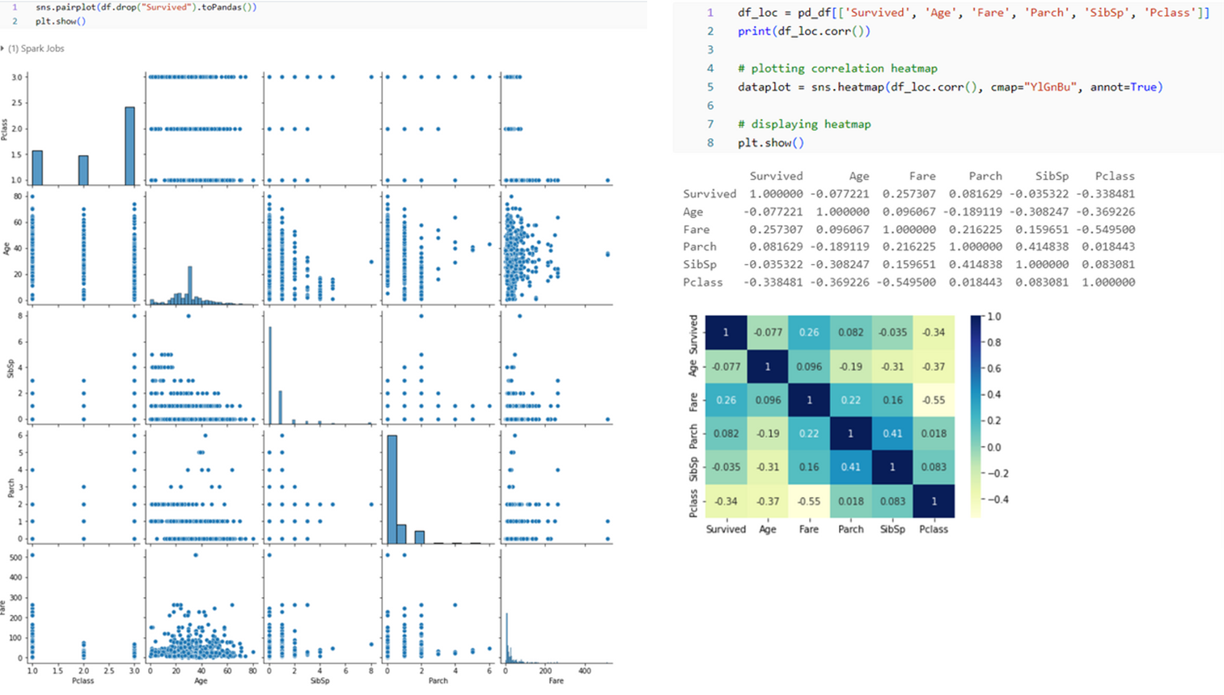

‘Survived’ and ‘Fare’ have a positive correlation, meaning that when the ticket price (Fare) increases, the probability of survival (Survived) also increases.

‘Age’ and ‘Survived’ have a negative correlation, meaning people with older ages have a lower chance of survival.

1. **Data Visualization**

**Compare elements to ML**

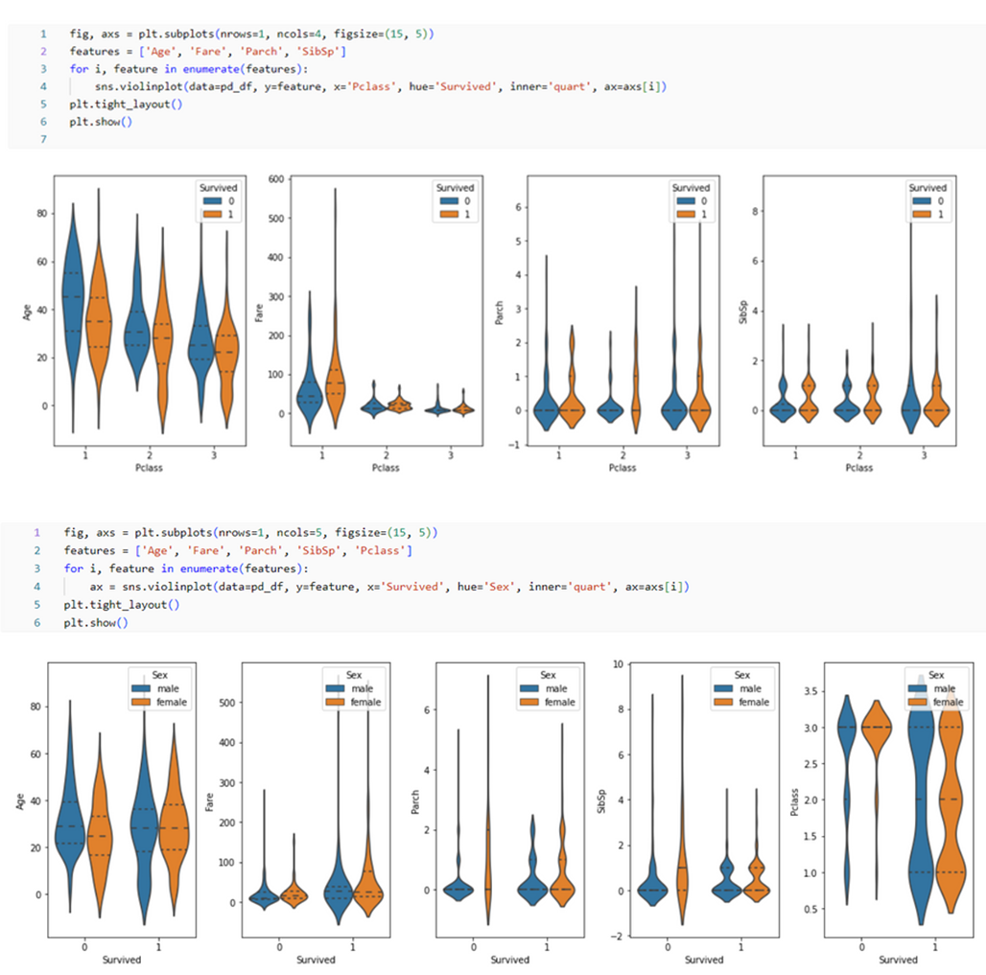

Violin plot: This plot shows the distribution of data and identifies variation between groups. The violin plots are divided into two:

1. Data set by **Pclass** (**Pclass**):

Four violin charts compare survival rates between three different classes on a ship.

Blue represents passengers who did not survive; Orange represents surviving passengers.

Each histogram shows a separate distribution pattern for survivors and non-survivors within each seat class.

2. Data set by gender (**Sex**):

Five violin charts compare survival rates between men and women in aspects such as age and fare.

Again, blue represents non-survivors; Orange represents survivors.

These graphs also show a distinct distribution pattern between the survival rates of male and female passengers.

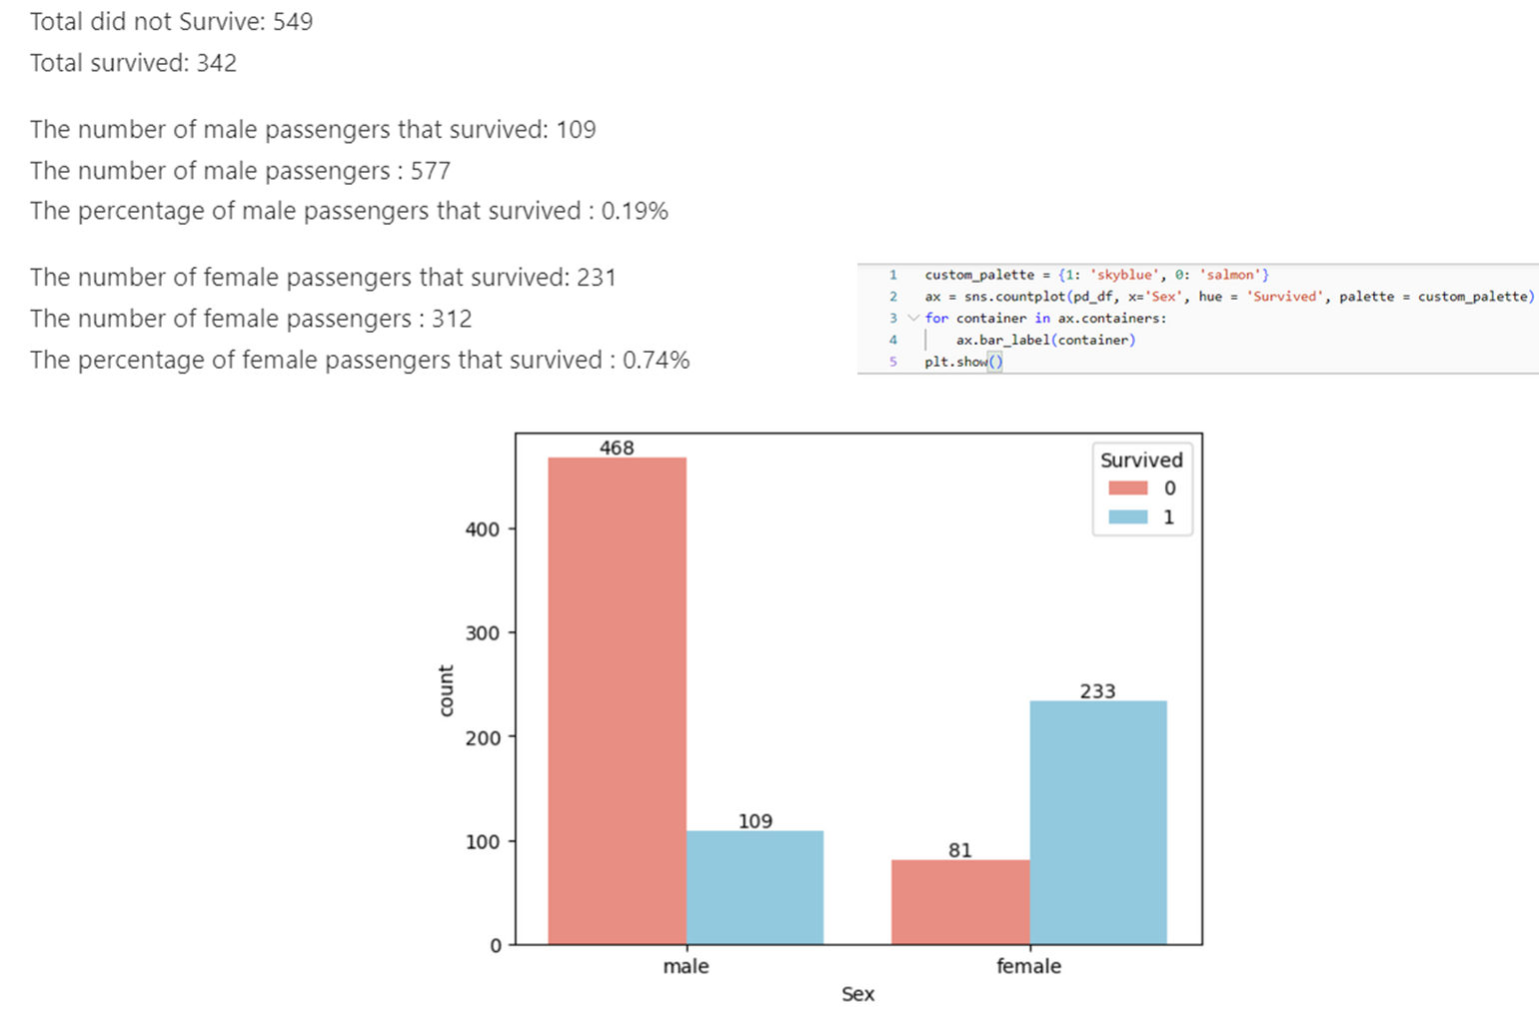**The death rate for men is lower than for women.**

**because historically, rescue ships have given priority to women**

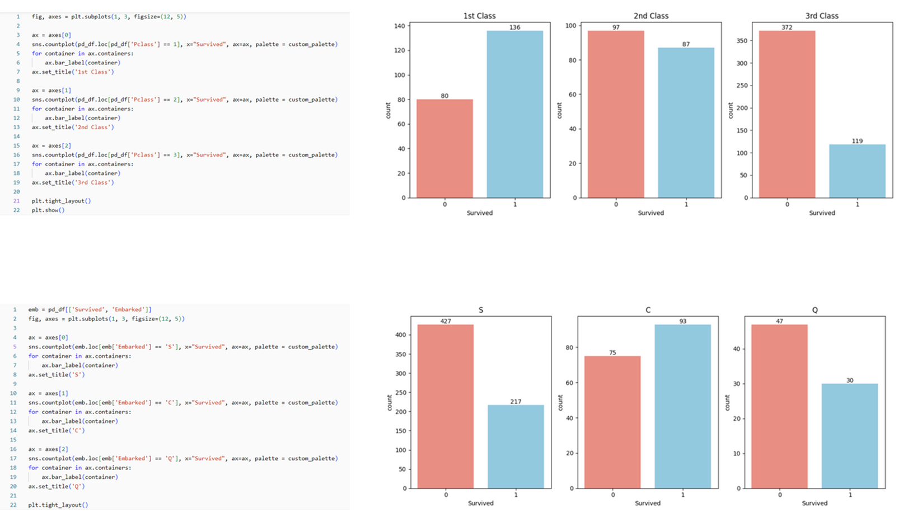

**First Chart:**

Compares survival rates among different Titanic passenger classes.

1st Class: More passengers survived.

2nd and 3rd Classes: More passengers did not survive.

**Second Chart:**

Analyzes survival rates by gender and class.

Females had higher survival rates across all classes.

1. **Machine Learning**

**Build and test model**

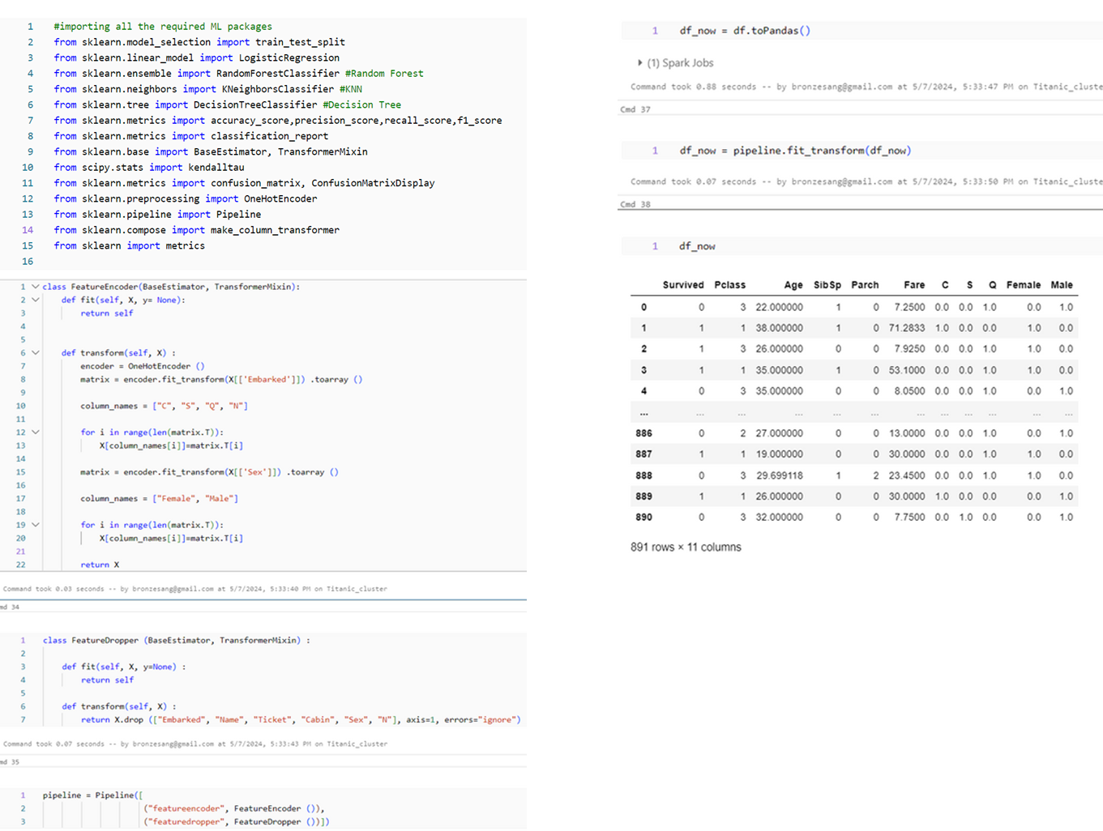

Import library for Machine Learning from **sklearn**.

Create 2 class to separate values into binary coefficients and drop some columns after transform

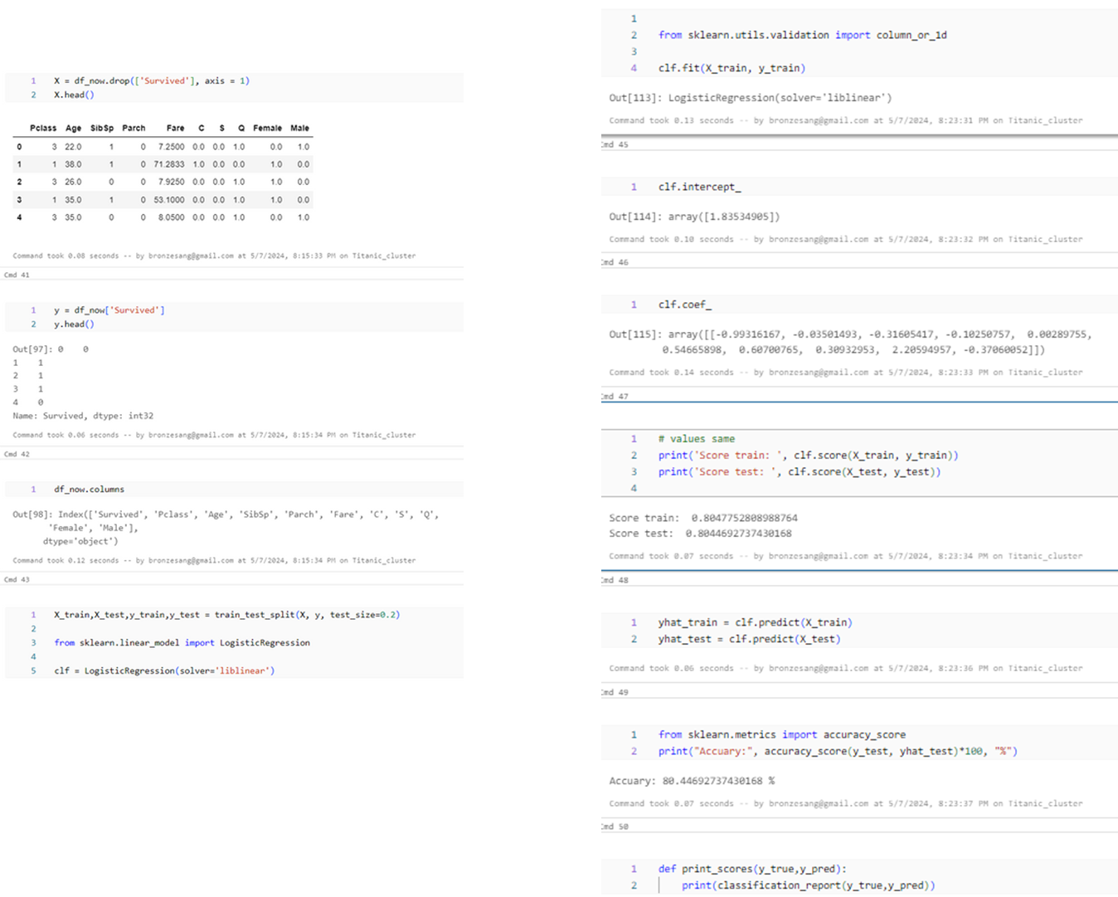

The model has almost the same training and testing scores and about **80%** has no **overfitting** or **underfitting**

**Confusion Matrix Display and compare some other models**

I have gained some insights from the EDA part. But with that, I cannot accurately predict or tell whether a passenger will survive or die. So now I will predict whether the Passenger will survive or not using some great Classification Algorithms. Following are the algorithms I will use to make the model:

1. **Logistic Regression**
2. **Random Forest**
3. **K-Nearest Neighbours**
4. **Decision Tree**

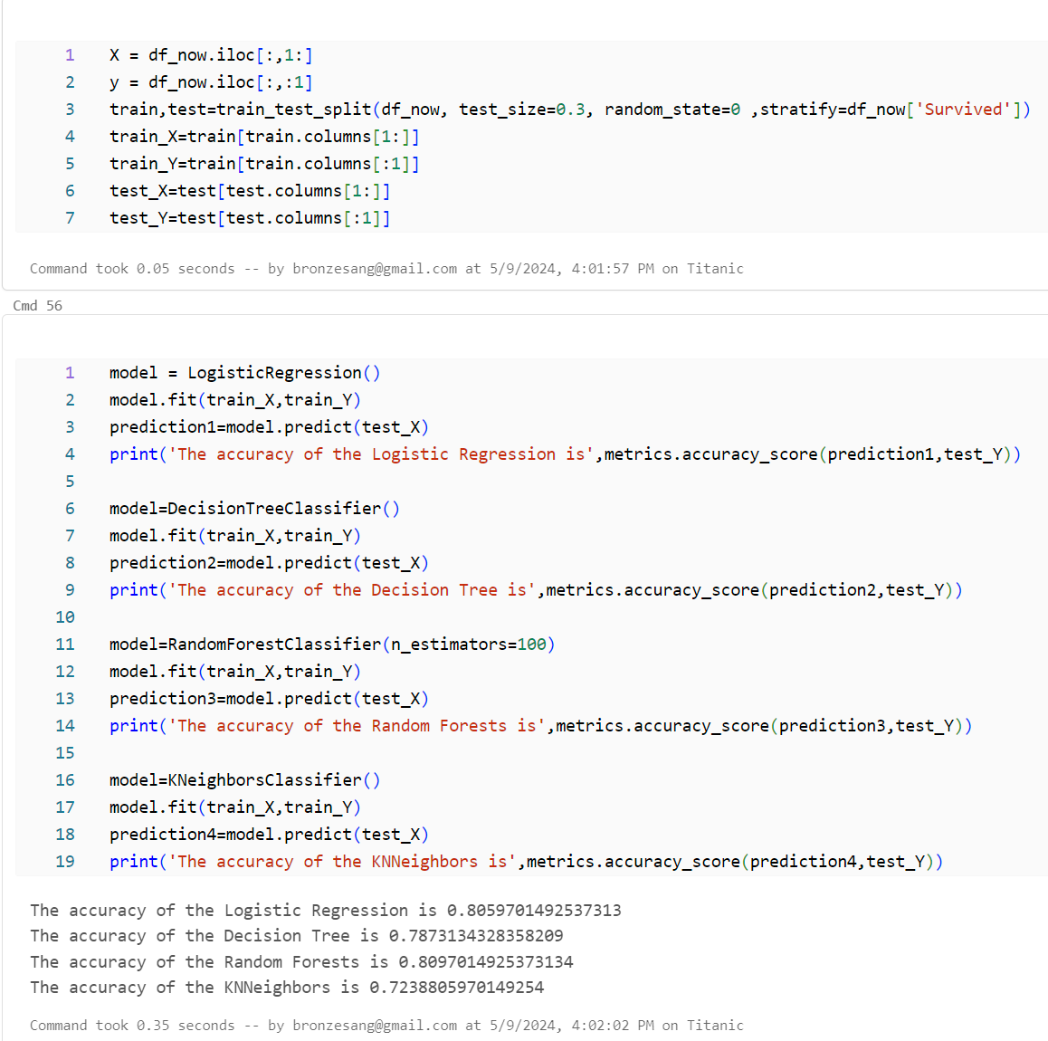

The accuracy of a model is not the only factor that determines the robustness of the classifier. Let's say that a classifier is trained over a training data and tested over the test data and it scores an accuracy of **90%.**

Now this seems to be very good accuracy for a classifier, but can I confirm that it will be 90% for all the new test sets that come over??. The answer is No, because I can't determine which all instances will the classifier will use to train itself. As the training and testing data changes, the accuracy will also change. It may increase or decrease. This is known as model variance.

To overcome this and get a generalized model, I use **Cross Validation**

**Cross Validation**

Many a times, the data is imbalanced, i.e there may be a high number of class1 instances but less number of other class instances. Thus I should train and test our algorithm on each and every instance of the dataset. Then I can take an average of all the noted accuracies over the dataset.

1)The K-Fold Cross Validation works by first dividing the dataset into k-subsets.

2)Let's say I divide the dataset into (k=5) parts. I reserve 1 part for testing and training the algorithm over the 4 parts.

3)I continue the process by changing the testing part in each iteration and training the algorithm over the other parts. The accuracies and errors are then averaged to get an average accuracy of the algorithm.

This is called K-Fold Cross Validation.

4)An algorithm may underfit over a dataset for some training data and sometimes also overfit the data for other training set. Thus with cross-validation, I can achieve a generalised model.

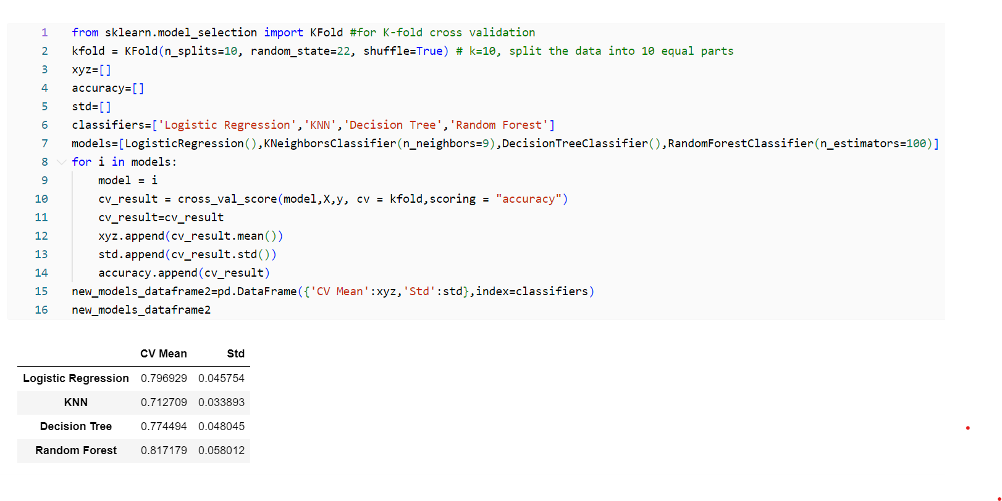

**Confusion Matrix**

It gives the number of correct and incorrect classifications made by the classifier.

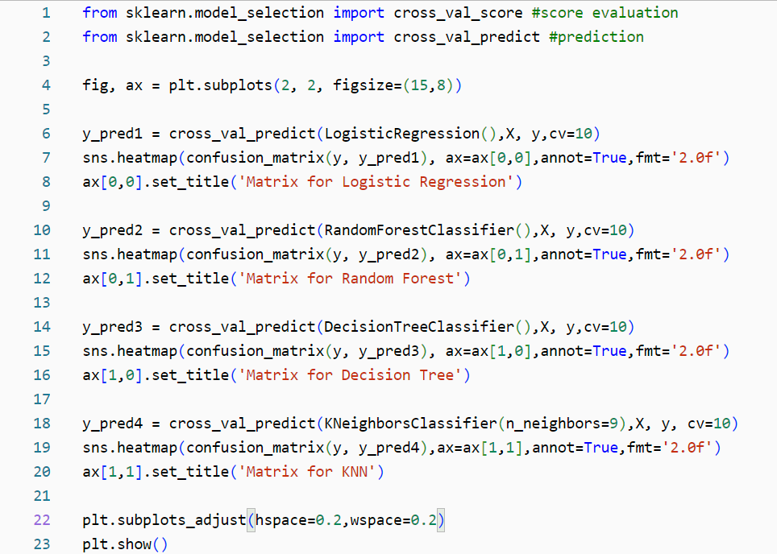

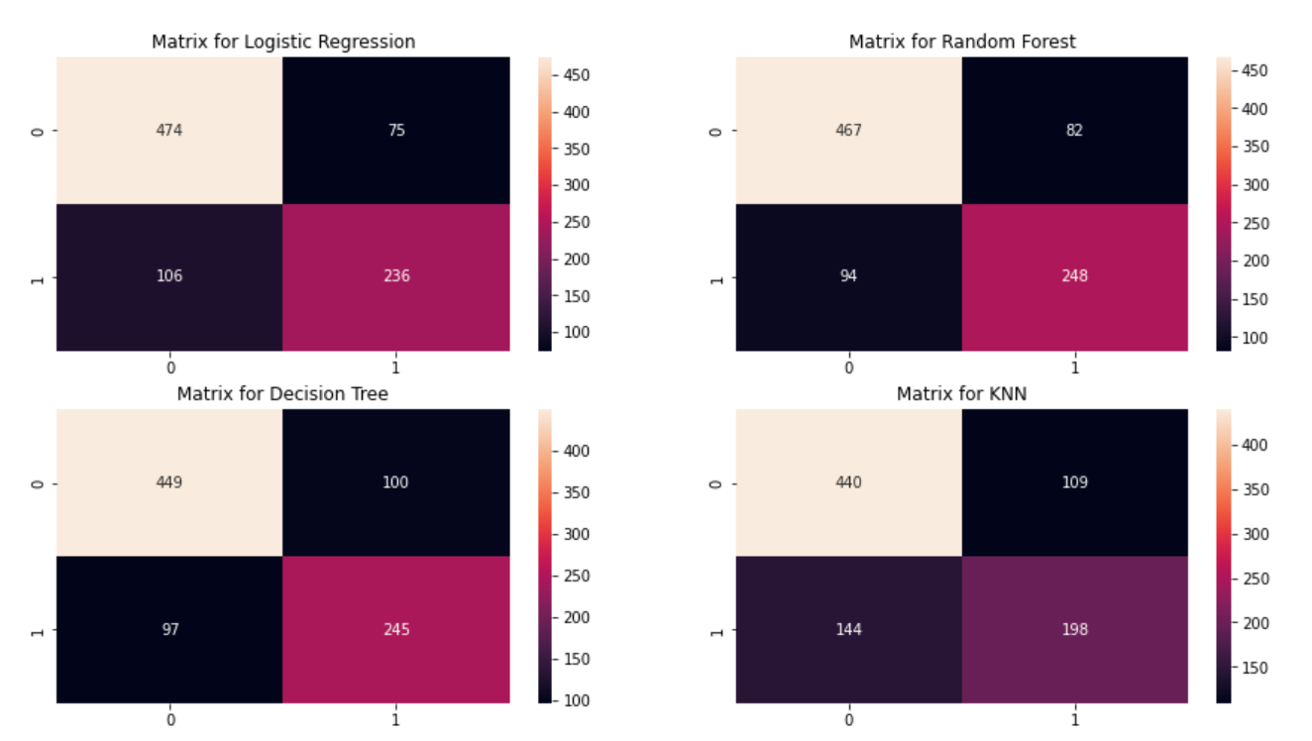

**Interpreting Confusion Matrix**

The left diagonal shows the number of correct predictions made for each class while the right diagonal shows the number of wrong prredictions made. Lets consider the first plot for Logistic Regression:

1)The no.1 of correct predictions are 474(for dead) + 236(for survived) with the mean CV accuracy being (474+236)/891 = 79.6% which I did get earlier.

2)Errors--> Wrongly Classified 75 dead people as survived and 106 survived as dead. Thus it has made more mistakes by predicting dead as survived.

By looking at all the matrices, I can say that Logistic Regression has a higher chance in correctly predicting dead passengers but Random Forest has a higher chance in correctly predicting passengers who survived.

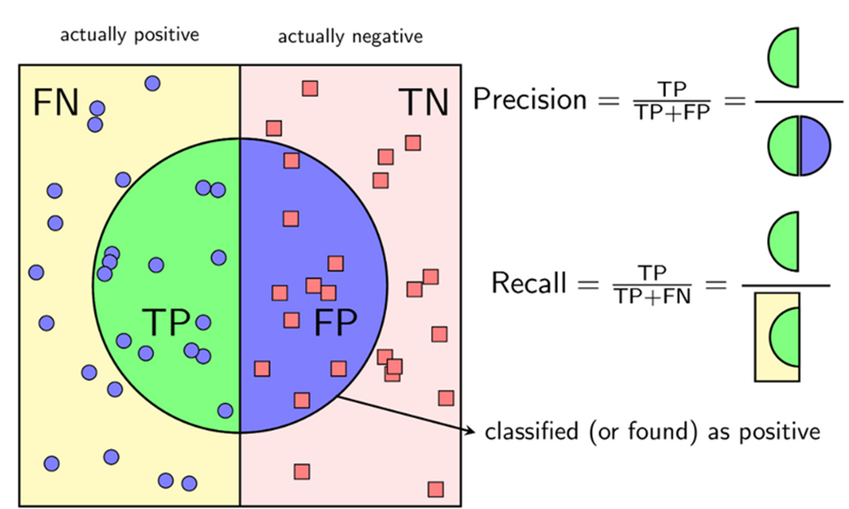

**Make prediction on Test data**

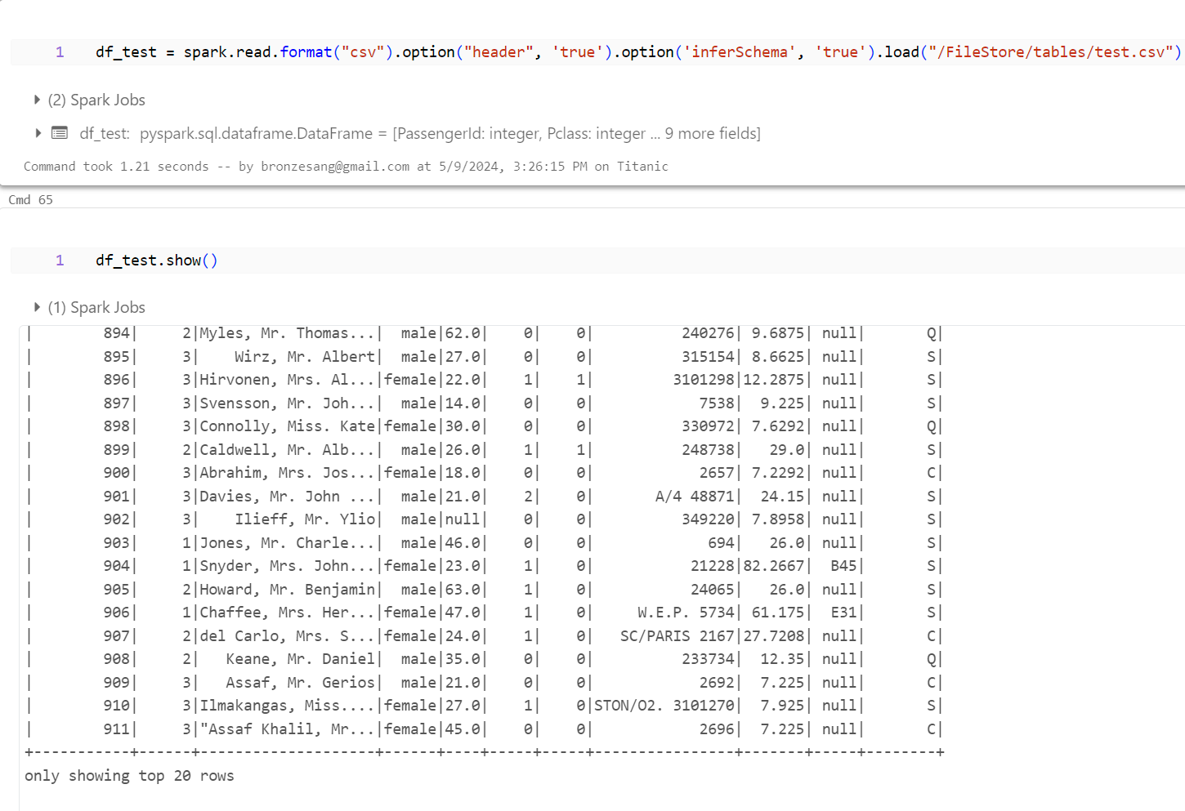Load file **test.csv,** show Dataframe

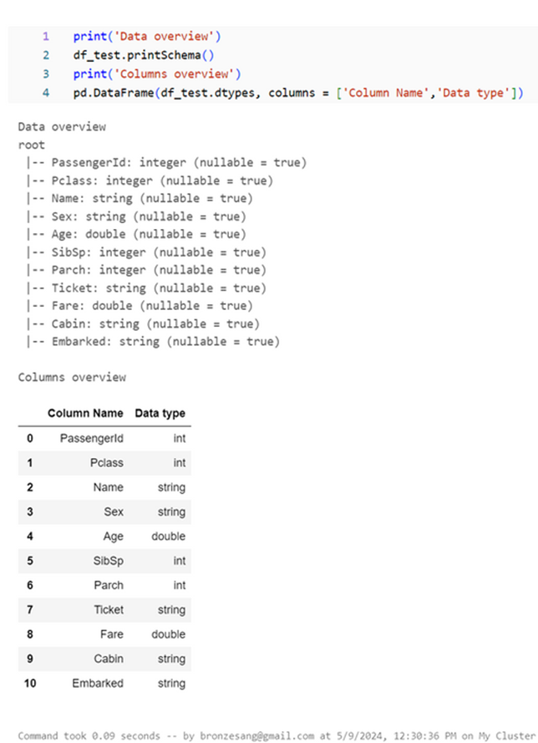

Check null values:

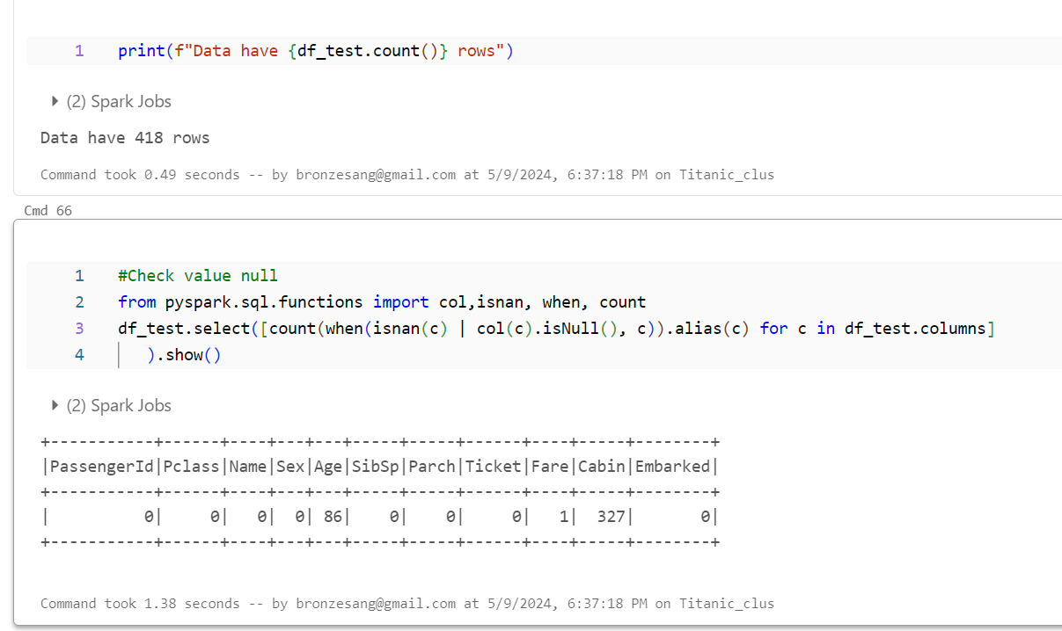

Column **‘Age’** have 86 elements, **‘Fare’** have 1 element

and fill mean column “**Age, Fare**”, drop column “**Cabin**”

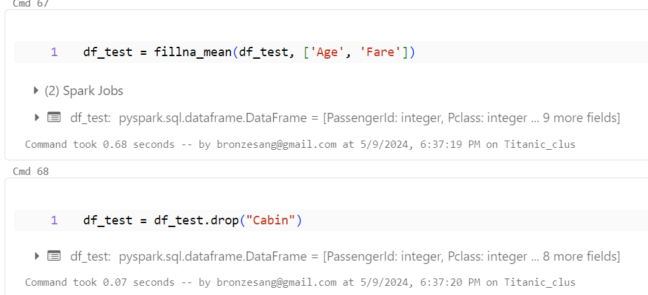

Transform **df_test** to **df_test_now**

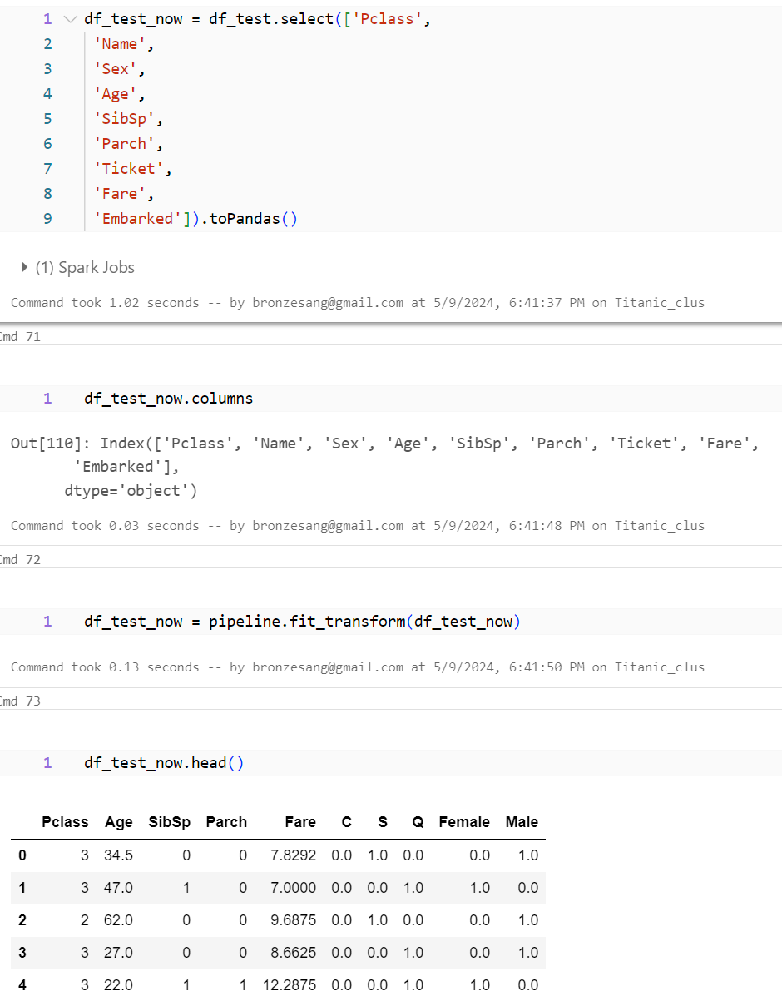

Make **Yhat_test_now** = predict column Survived to df_test_now[‘Survived’]

Check data again

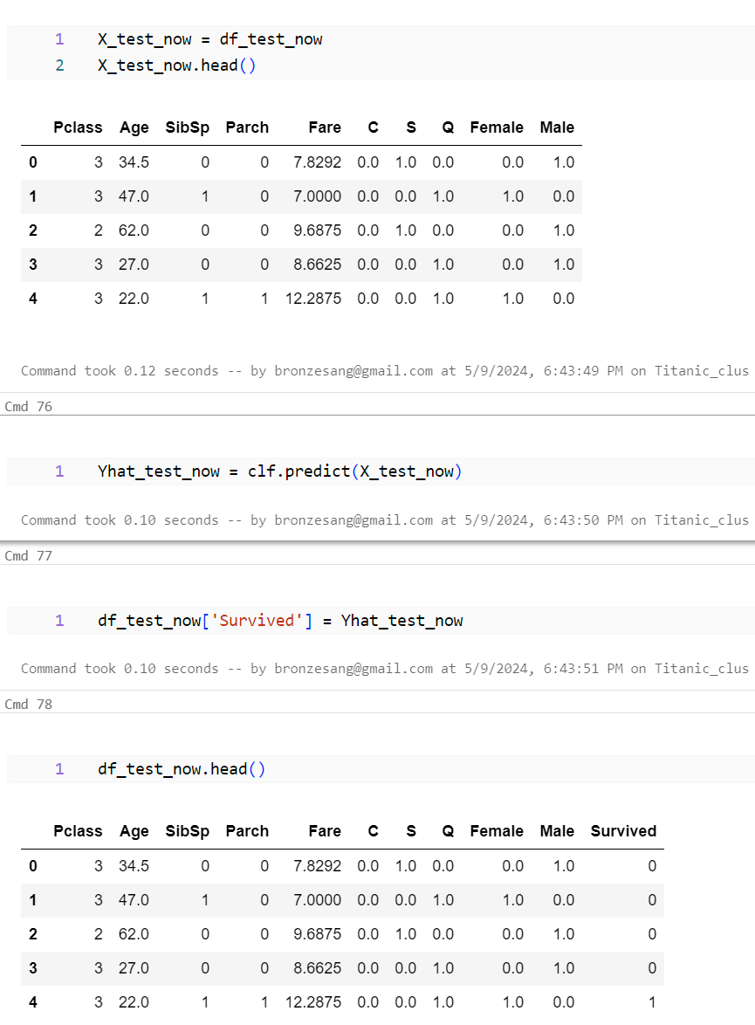

Make column **Survived** to **df_test**

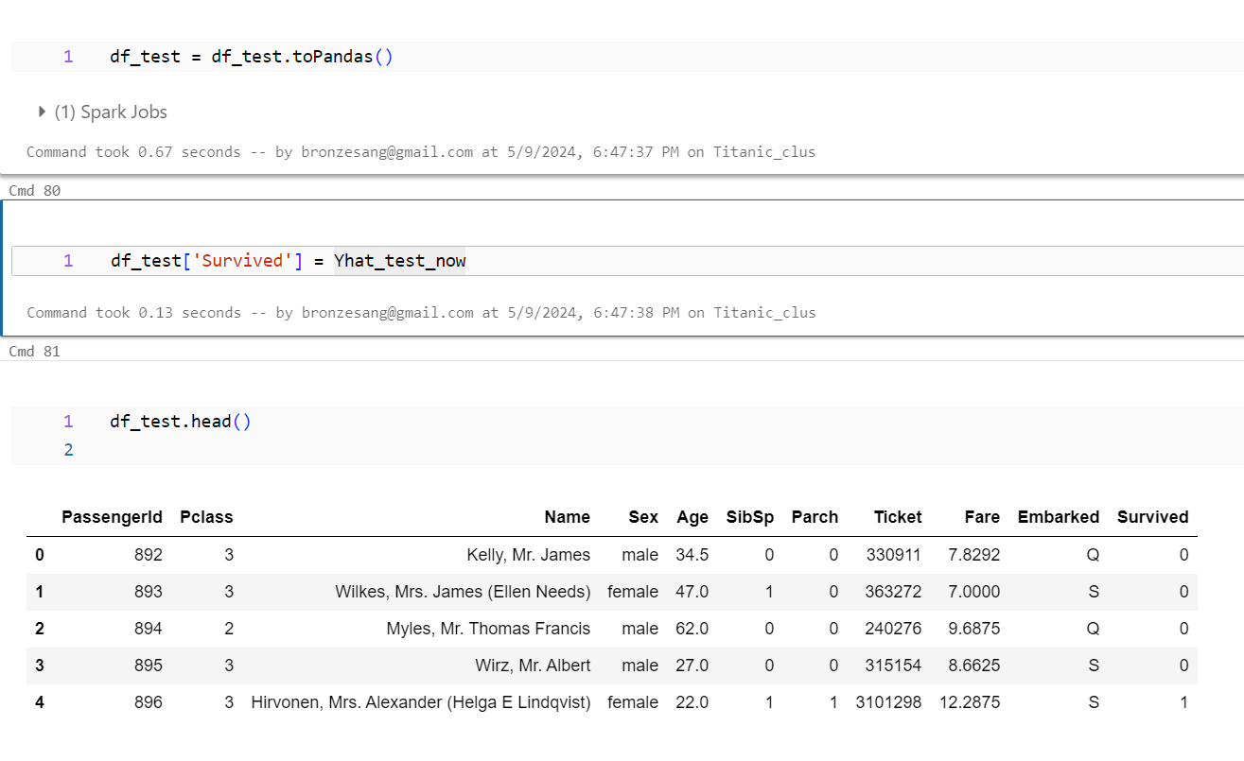

**Pipeline**

I use Pipeline for predict data **train.csv** and compare data **test.csv**

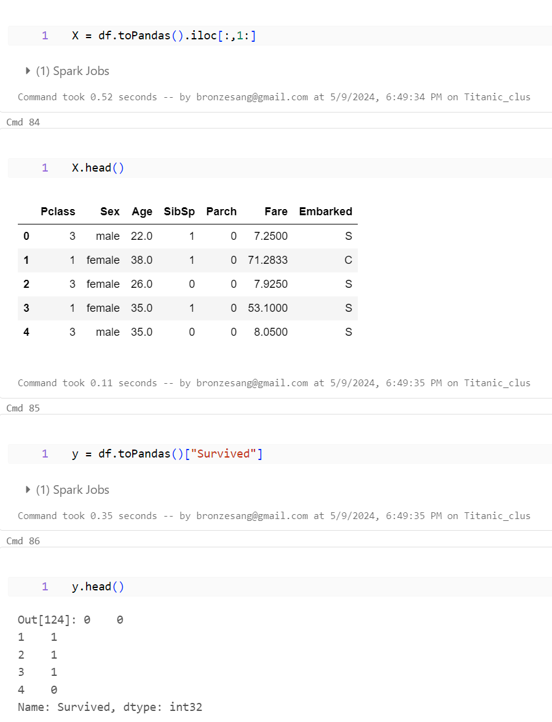

Make **Input** with **OneHotEncoder()**

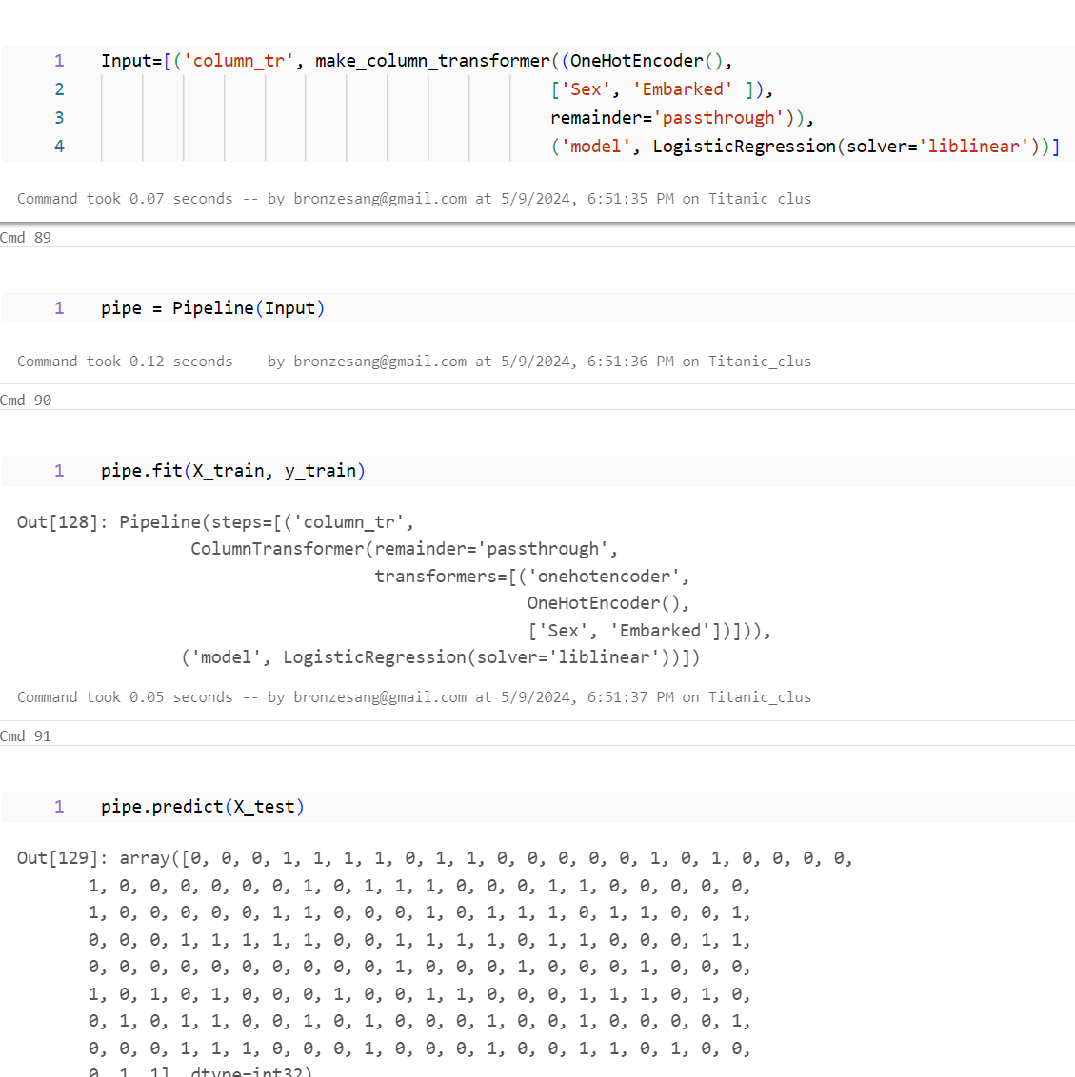

Pipe.predict(X_test)

Check score(train, test)

y_new = pipe.predict(data_pipe) it contains predict values from pipeline

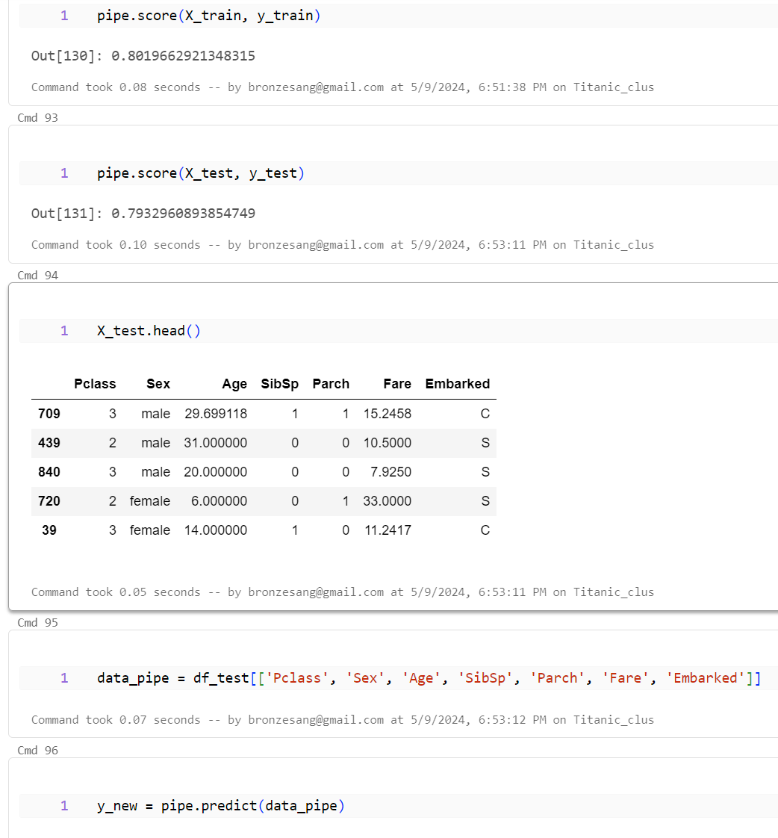

Make column **“Survived_new”** = y_new

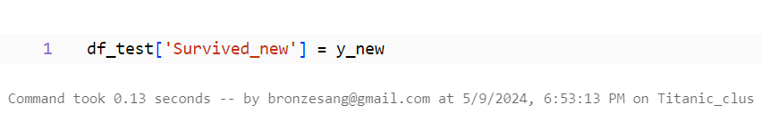

Draw bar chart check number of people died and survived of 2 predict columns

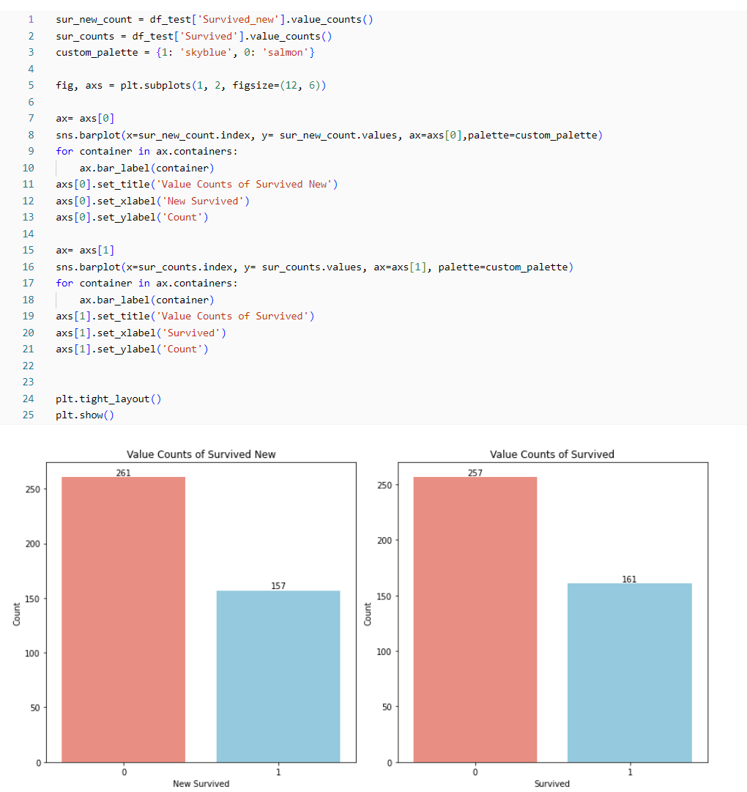

We can see columns **Survived** and **Survived New** just the other 8 elements

So the model can be accepted because the error is not much

Save df_test to new csv

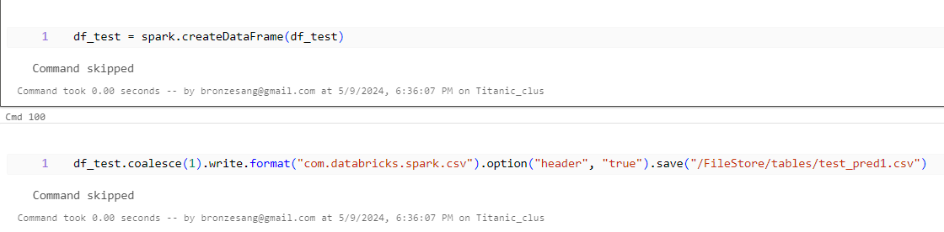

check csv

